Week4

a.

We completed all tasks on class:

- We updated all functions.

- We finished D controller (with neutral_power = 1300 and Kd = 100)

- We finished PD controller (Kp = 1.8, Kd = 100)

- We finished PID controller (Kp = 3.6, Kd = 200, Ki = 0.005)

b.

1) What went well:

- We finished P/PD/PID controller easily.

2) What did not go well:

- We could not tune PD to a good balance, and spent a lot of time on tuning. Finally, we found the reason was noise. We adjusted the complementary filter A = 0.002 (from A = 0.02), and then tuned it to a good balance easily.

- We found that when just used PD controller, the location of battery would affect the balance position.

3) What will you change for next class.

- Read every tip carefully.

c. - Eric 50%

- Hong 50%

We learn and do everything together, and contribute evenly to our job.

d. Attached codes

Kp = 1.8, Kd = 100 (good PD controller) 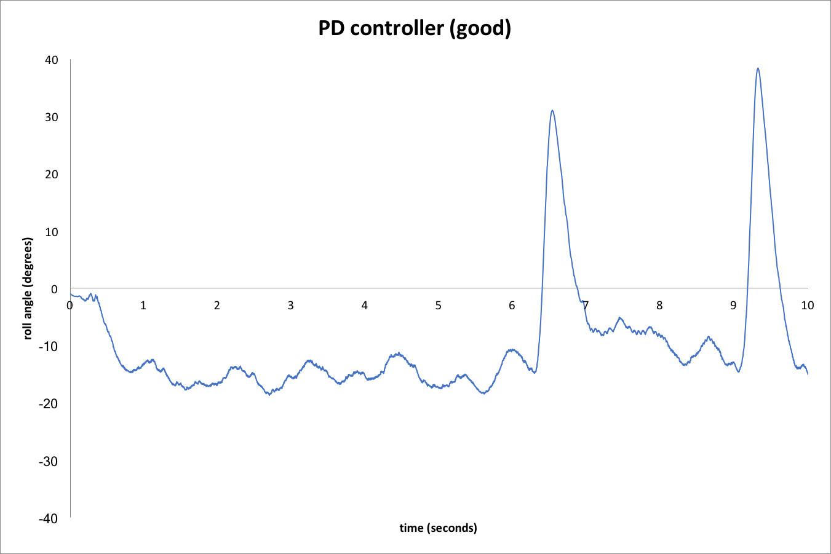

Kp = 3, Kd = 100 (bad PD controller)

